Android multi-app

First thing first, if the Android environment does not work with the brand new RN app, don’t forget to change Gradle SDK from 1.8 to 11:

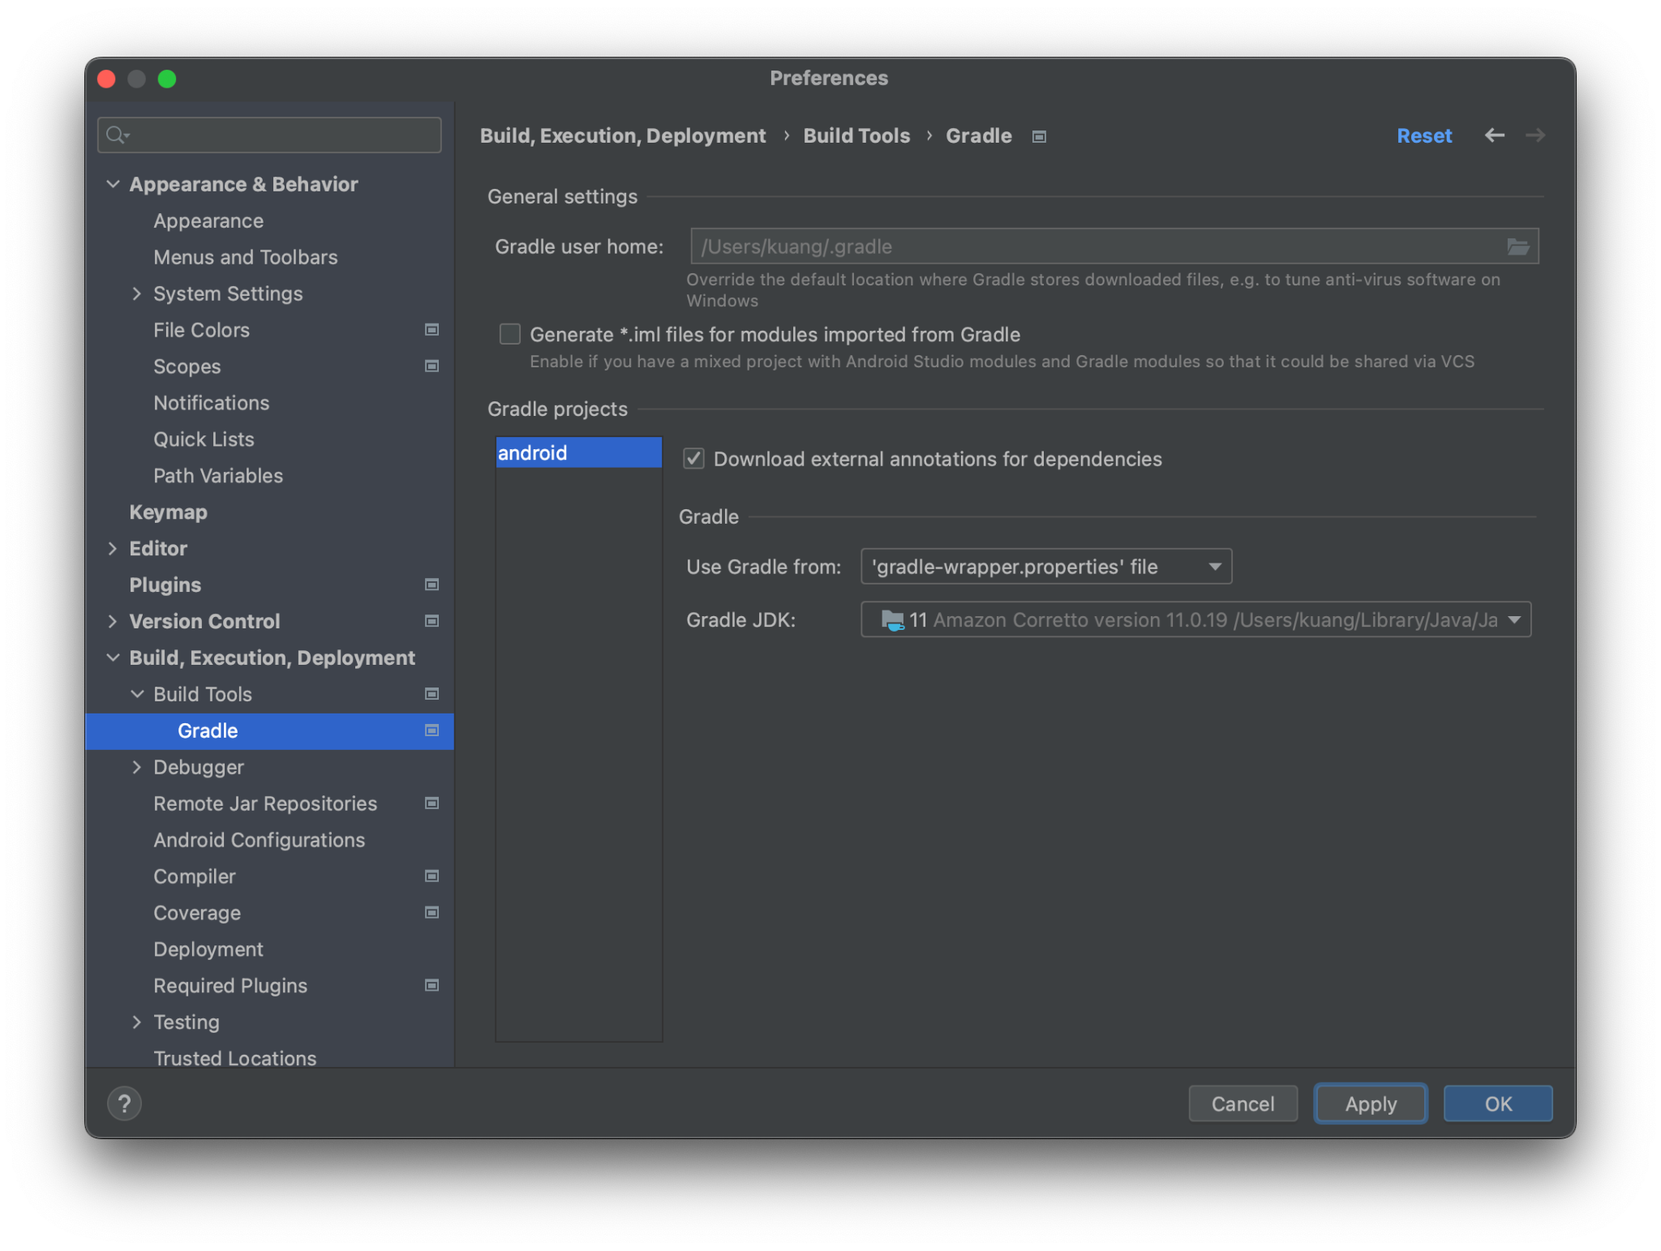

(1) Create the second app `app2` within the same Android project

In Terminal,

`cd <RN_APP_ROOT>/android`

`mkdir app2 && cd app2`

`cp -R ../app/* .

In `android/settings.gradle` add `app2`

```

rootProject.name = 'app'

apply from: file("../node_modules/@react-native-community/cli-platform-android/native_modules.gradle"); applyNativeModulesSettingsGradle(settings)

include ':app'

include ':app2'

includeBuild('../node_modules/@react-native/gradle-plugin')

```

In `android/app2/build.gradle` change applicationId

```

applicationId "com.app2"

```

In `android/app2/src/main/java/com/app/MainActivity.java` change JS app to `app2`

```

public class MainActivity extends ReactActivity {

/**

* Returns the name of the main component registered from JavaScript. This is used to schedule

* rendering of the component.

*/

@Override

protected String getMainComponentName() {

return "app2"; // Change this to "app2" to load "app2"'s JS bundle

}

...

}

```

In `android/app2/src/main/res/values/strings.xml` change app2’s display name

```

<resources>

<string name="app_name">app2</string>

</resources>

```

(2) Run app2

In Terminal start Metro for app2

`cd <RN_APP_ROOT>/packages/app2`

`yarn start`

From Android studio choose app2 to run

